**PROVISIONAL APPLICATION FOR PATENT COVER SHEET**

**Page 1 of 1**



**REQUEST FOR FILING A PROVISIONAL APPLICATION FOR PATENT**

*Under 37 CFR 1.53(c)*



**INVENTOR(S)/APPLICANT(S)**

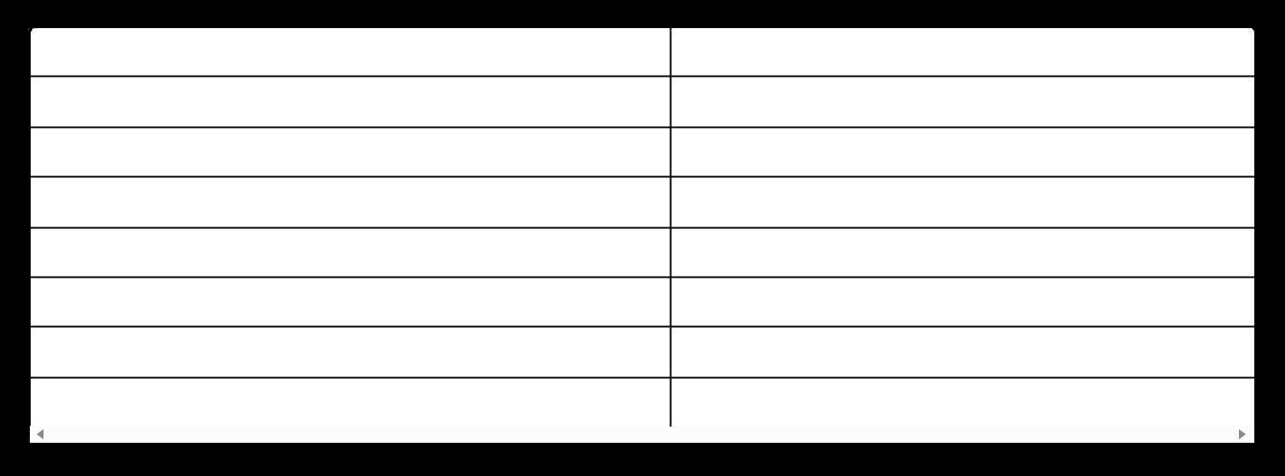

**Field**

**Given Name**

**Middle Name**

**Family Name**

**City**

**State**

**Country**

**Postal Code**

**Information**

Brian

James

Rutherford

Wimberley

TX

US

78676-3114

**TITLE OF THE INVENTION**

**Quantum Side-Channel Defense System for Post-Quantum Cryptographic Implementation Protection within MWRASP Total Defensive Cybersecurity Platform**



**CORRESPONDENCE ADDRESS**

Brian James Rutherford

6 Country Place Drive

Wimberley, TX 78676-3114

United States

**Telephone:** (512) 648-0219

**Email:** [Actual@ScrappinR.com](mailto:Actual@ScrappinR.com)



**ENTITY STATUS**

* **MICRO ENTITY** - Applicant certifies micro entity status. See Form PTO/SB/15A attached.



**DOCKET NUMBER**

**RUTHERFORD-015-PROV**



**APPLICATION ELEMENTS**

Check all that apply:

* **Specification** - Number of Pages: [TO BE DETERMINED]
* **Drawing(s)** - Number of Sheets: 12
* **Application Data Sheet** - See 37 CFR 1.76
* **Micro Entity Status Certification** - Form PTO/SB/15A



**THE APPLICANT CLAIMS PRIORITY TO:**

* This application claims priority to: N/A (First filing in patent family)



**ACCOMPANYING APPLICATION PARTS**

* Assignment Papers
* 37 CFR 3.73(c) Statement
* Power of Attorney
* English Translation Document
* Information Disclosure Statement (PTO/SB/08)
* Preliminary Amendment
* Return Receipt Postcard (MPEP 503) ☐ Certified Copy of Priority Document(s)

☐ Nonpublication Request under 35 U.S.C. 122(b)(2)(B)(i) ☐ Other: _______________



**SIGNATURE**

**Signature:** /Brian James Rutherford/

**Date:** _______________

**Name:** Brian James Rutherford

**Registration Number:** N/A (Pro Se)



**EFS-Web Provisional Filing**

**First Filing in Patent Family**